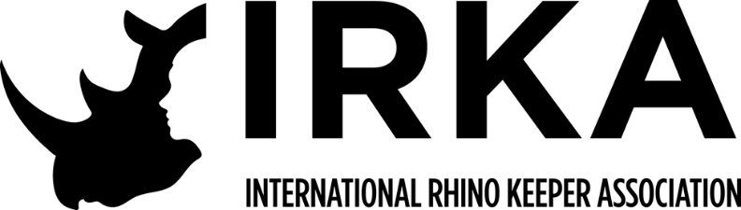
INTERNATIONAL RHINO KEEPER ASSOCIATION
Keeper Professional Development
Program Guidelines
APPLICANT INFORMATION
General:
The International Rhino Keeper Association (IRKA) has developed a
program that will provide rhino keepers the opportunity to expand their
knowledge and husbandry experience. This program has been designed to
enable rhino keepers to work at other institutions to familiarize themselves with
different management styles. Due to the professional nature of this program, it is
only available to Professional members.
The IRKA has selected facilities with different management styles to
maximize the keepers’ potential for enhancing their expertise. It is the hope of
the IRKA that the institutions participating in this program will take this
opportunity to share their trials, tribulations, triumphs and successes with their
professional colleagues. At this time, the hosting institutions are: Busch Gardens
Tampa, Cincinnati Zoo & Botanical Gardens, The Wilds, Fossil Rim, African Rhino Protection Initiative,
White Oak Conservation Center, San Diego Zoo Safari Park, and Denver Zoo. The concept of the
program is quite simple, but we feel it is an invaluable tool for expanding the
skills of rhino keepers by providing them the opportunity to work alongside their
colleagues and learn the nuances of that institution’s husbandry practices.
Approval process:
The keeper participating in this program must not only have their
institution’s authorization, but agreement to pay their wages. The institution’s
approval requires that employee is covered by their institution’s workmen’s
compensation and will provide documentation of personal health insurance. This
will provide assurance that the hosting institution will not be liable to cover
medical costs.
When application has been approved, there will be a fee of $10 to be
contributed to the IRKA scholarship fund.
Submission criteria:
Completed application should be sent to Keeper Professional Development
Chairperson, Joe Hauser
E-mail Address: Joe.Hauser@TxRhino.org
Funding program:
• Requires completion of a funding application available through our website
• There is a limited reimbursement funding program available for expenses
incurred during this program.
• Applications must be received by January 1st through June 1st for program
participation occurring in the first six months of the year and June 2 through
December 1st for program participation during the later part of the year.
• Funding applications will not be kept on file
• Individuals receiving financial support from IRKA, will be required to submit a
brief summary of their experiences, etc. to organization newsletter, The
Crash, for inclusion in future issue.
INSTITUTIONAL INFORMATION
Responsibilities of the keeper’s institution:
It will be the responsibility of the keeper’s institution, or the keeper him/
herself, to cover any expenses including travel, housing (if necessary) and food.
The keeper’s supervisor must complete the section of the application in regards
to workman’s compensation plan and information in regards to employee’s
medical coverage. As stated in the application, please include any additional
documentation your institution may require to participate in this program.
Responsibilities of the hosting institution:
The International Rhino Keeper Association would simply ask the hosting
institution to be willing to let interested and approved applicants work alongside
their professional staff. We would like each institution to allot a time frame that
they could offer this program to interested individuals and let the association
know their specific details. Each facility’s time allotment will dictate the amount
of time available and subsequently the number of keeper(s) that could participate
in this program. We would also like to solicit input from institutions regarding
options that may be available in regards to housing in an attempt to reduce the
expense(s) to the participants. We would also ask that these institutions provide
any additional documentation that might be required so they can be completed in
a timely manner. The final decision regarding applicant’s acceptance into the
program is based on input by the hosting institution. A candidate for the program
can be rejected by the hosting institution, even though they may have already
received approval from their institution and/or IRKA. Hosting institution will not
be responsible for employee’s wages during keeper professional development at
their institution.

